**UNEARTHING THE ENVIRONMENTAL IMPACT OF HUMAN ACTIVITY: A GLOBA CO2 MISSION ANALYSIS**

**INTRODUCTION**

Global warming is one of the biggest challenges currently being faced by the human race, although correlation is not causation, a likely cause of global warming is due to increased atmospheric carbon dioxide from human activities. **CO2 Emission** refers to the Carbon Dioxide emitted throughout the world. For this analysis we will be focusing on CO2 Emissions and its effect on the world we live in as well as some key factors and stats that may play a role in the emission of CO2 globally. Fossil fuel use is the primary source of CO2. The data throws light onto how much fossil fuels are burnt, per year per nation, which amounts to an increase in CO2 every year. This will help researchers and environment experts to predict global warming. So countries should set a goal to decrease this amount yearly.

Analysing Global Co2 Emission across countries from 1975 to 2020. This dataset contains a record of Co2 Emission by each Country and Region of Earth, here we are going to analyse and visualise Country wise, Region wise and Overall Co2 Emission on Earth.

**PURPOSE:**

Put simply, net zero means we are not adding new emissions to the atmosphere. Emissions will continue, but will be balanced by absorbing an equivalent amount from the atmosphere.

Practically every country has joined the [Paris Agreement](https://unfccc.int/process-and-meetings/the-paris-agreement/the-paris-agreement) on climate change, which calls for keeping the global temperature to 1.5°C above pre-industrial era levels. If we continue to pump out the emissions that cause climate change, however, temperatures will continue to rise well beyond 1.5, to levels that threaten the lives and livelihoods of people everywhere.

This is why a growing number of countries are making commitments to achieve carbon neutrality, or "net zero" emissions within the next few decades. It’s a big task, requiring ambitious actions starting right now.

Net zero by 2050 is the goal. But countries also need to demonstrate how they will get there. Efforts to reach net-zero must be complemented with adaptation and resilience measures, and the mobilization of climate financing for developing countries.

LITERATUR SURVEY:

A literature survey is a method of researching existing literature and studies related to a specific topic. In the context of analyzing the Global Co2 Emission, a literature survey would involve reviewing studies and articles that have been published on the topic of Emission, as well as studies specific to Co2.The literature survey would include sources such as academic journals, industry reports, and online articles. It would aim to identify different internal and external factors that are responsible and commonly used to determine Co2 Emission, as well as any best practices or strategies that have been identified for reducing emission.The literature survey would also explore any existing research on Co2 Emission specifically, and would aim to identify any challenges or opportunities that the Countries can opt to reduce emission.

SPECIFY THE BUSINESS PROBLEM:

Global warming is one of the biggest challenges currently being faced by the human race, although correlation is not causation, a likely cause of global warming is due to increased atmospheric carbon di oxide from human activities.

**Co2 emission** refers to carbon di oxide emitted throughout the word. Analysing global Co2 emission across countries from 1975 to 2020.

**EMPATHY MAP**

It gives the detailed view about the problem (ie, A global co2 emission analaysis)

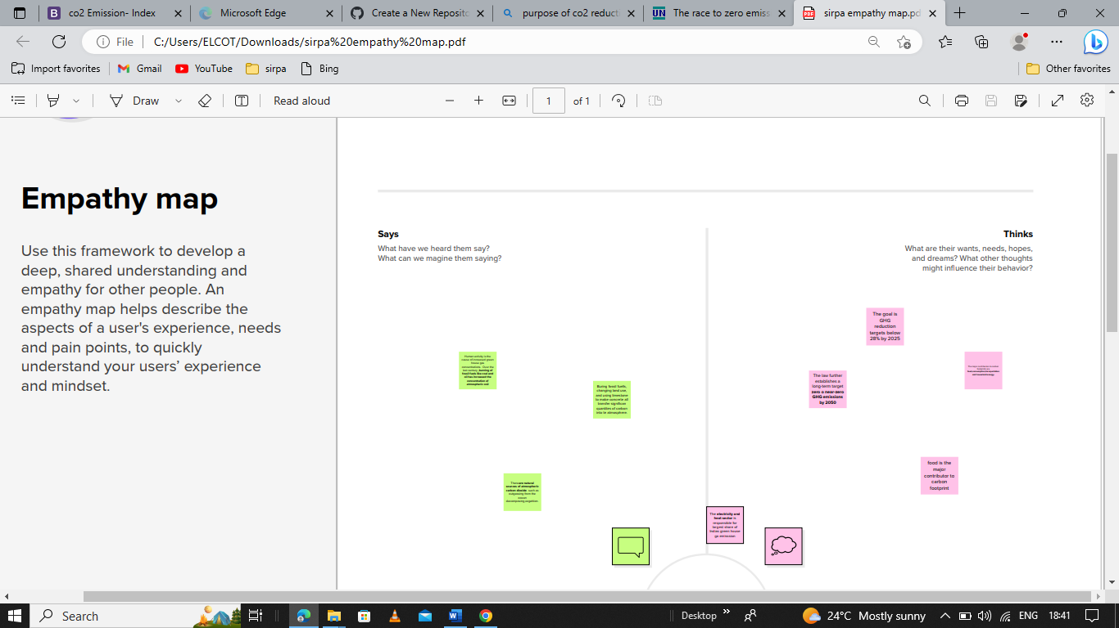

SOCIAL OR BUSINESS IMPACT:

After collecting the data set that contain a Co2 emission from 1975 to 2020, we analyse it deeply.

The data is initially pre-processed using excel, it contains,

* Country -Country for which Co2 is recorded.
* Year-Year the data was recorded
* Co2 emission in million metric tons
* Co2 growth per capita
* Cummulative Co2
* Sever fossil fuel rate of emission

**BRAINSTORMING IDENTIFICATION**

It tells about the needs , hopes to recover and what are the problems that came in future , and it also speaks about the people opinions and thoughts (in what way they think and handle the matter).

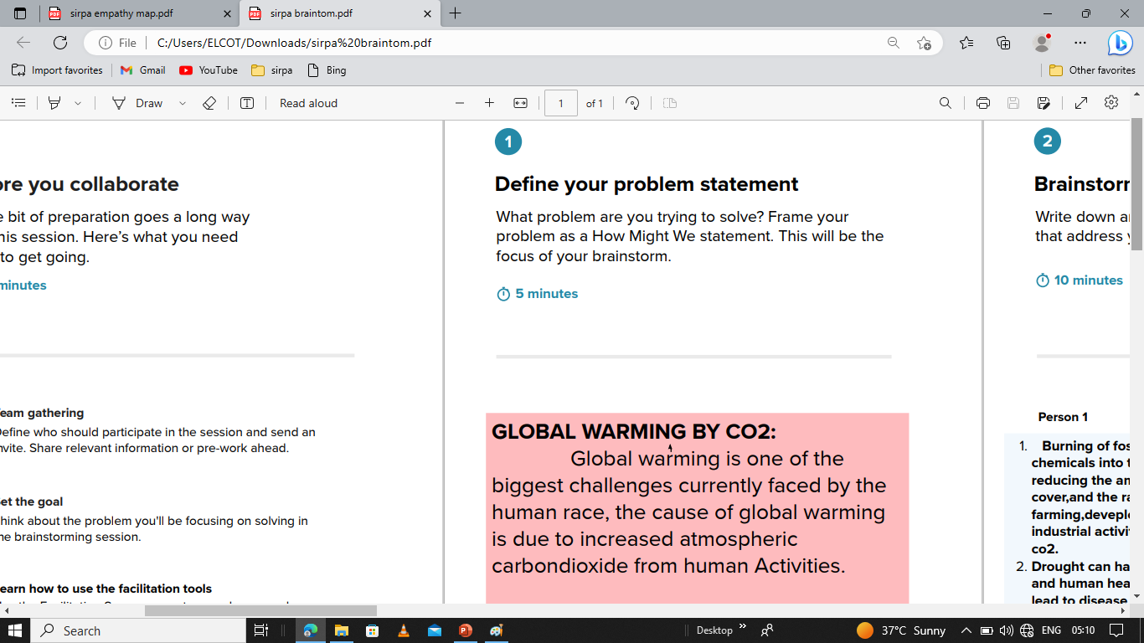

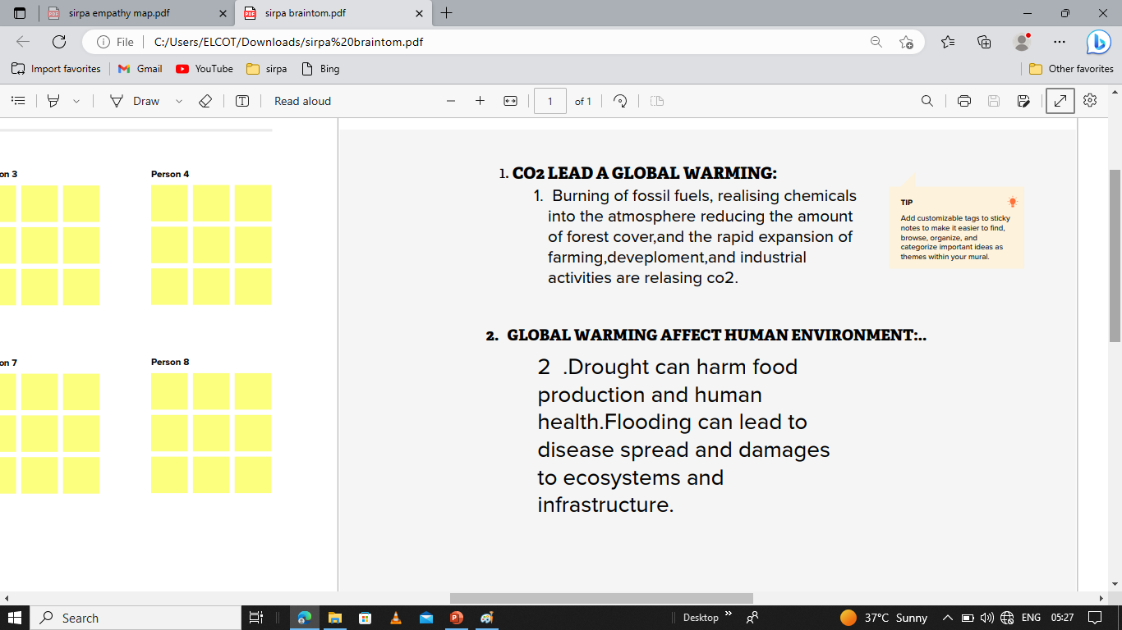

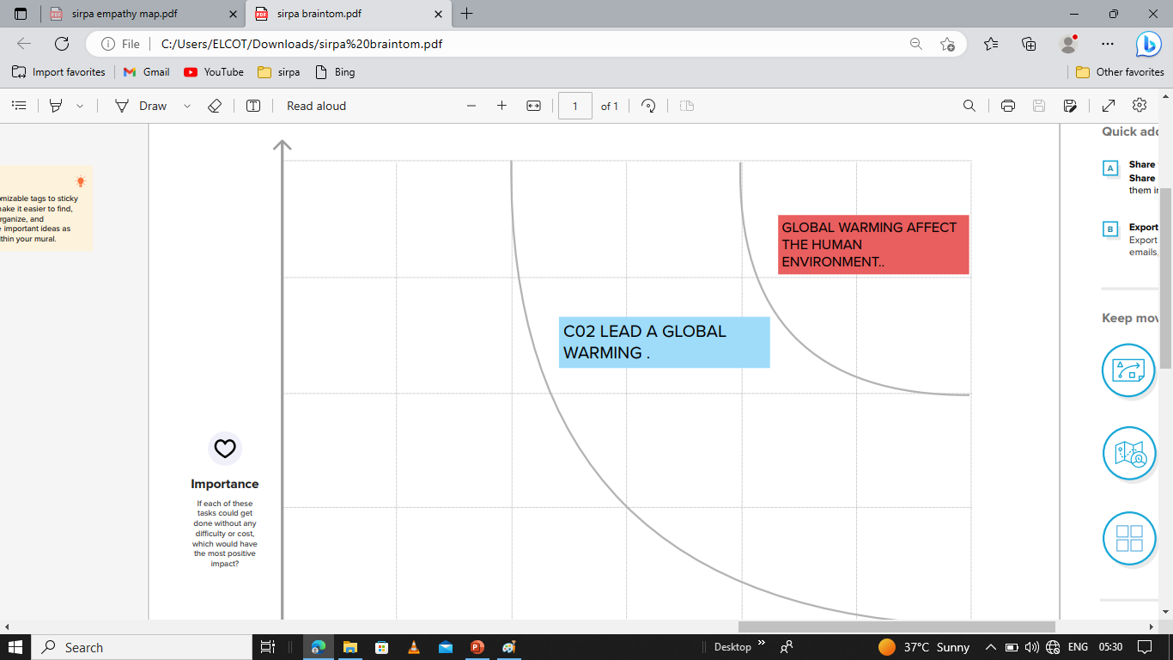

DATA PREPARATION:

**PREPARE THE DATA FOR VISUALIZATION**

Preparing the data for visualization involves cleaning the data to remove irrelevant (or) using data, transforming the data into a format that can be easily visualized.

DATA VISUALIZATION

Data visualization is the process of creating graphical representation of the data in order to help the people understand and explore the information. It include the charts and graphs like pie chart, bar chart ,bubble chat and line chart etc.,

TO UNDERSTAND TOTAL WORLD CO2 EMISSION; CO2 EMISSION OVER TIME; TOTAL EMISSION BY CONTINENTS:

**TOTAL WORLD CO2 EMISSION**

Global carbon di oxide (Co2) emission from energy combustion and industrial process 1  **grew 0.9% (or) 321Mt in 2022 to a new all- time high of 36.3Gt.**

China currently emits the highest level of Co2 annually it has emitted for less than the **united states**  one the past three centuries.

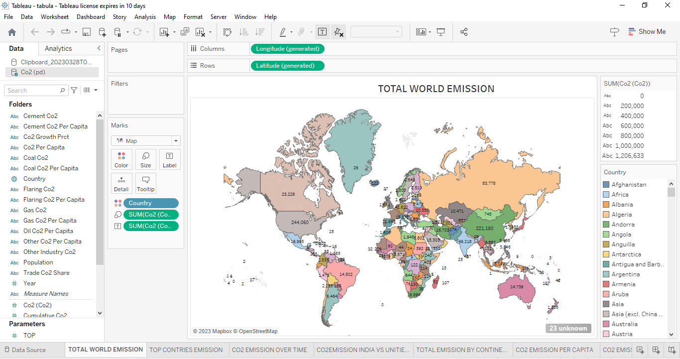

From the above map we understand that Asia I by far the largest emitter, accounting for 53% of global emissions. As it is **home to 60%**  of the world’s population this mean that per capita emissions in Asia are sightly lower than the world average, however.

China is, by a significant margin, Asia’s and the world’ largest emitter: it emits nearly 10 billion tonnes each year, more than one-quarter of global emissions.

North America-dominated by USA-is the second largest regional emitter at 18% of global emissions. It’s followed closely by Europe with 17%.

**CO2 EMISSION OVER TIME:**

The  **United States**  was the biggest emitter in history as of 2020 having released 422 billion metric tons of carbon dioxide (GtCo2) into the atmosphere since the birth of th industrial revolution. This accounted for roughly a quarter of all historical Co2 produced from fossil fuels and industry. India jump 2 spots higher, and is now ranked 8th  as per Climate Change Performance Index(CCP 2020) published by German Watch, New climate Institute and Climate Action Network International based in Germany.

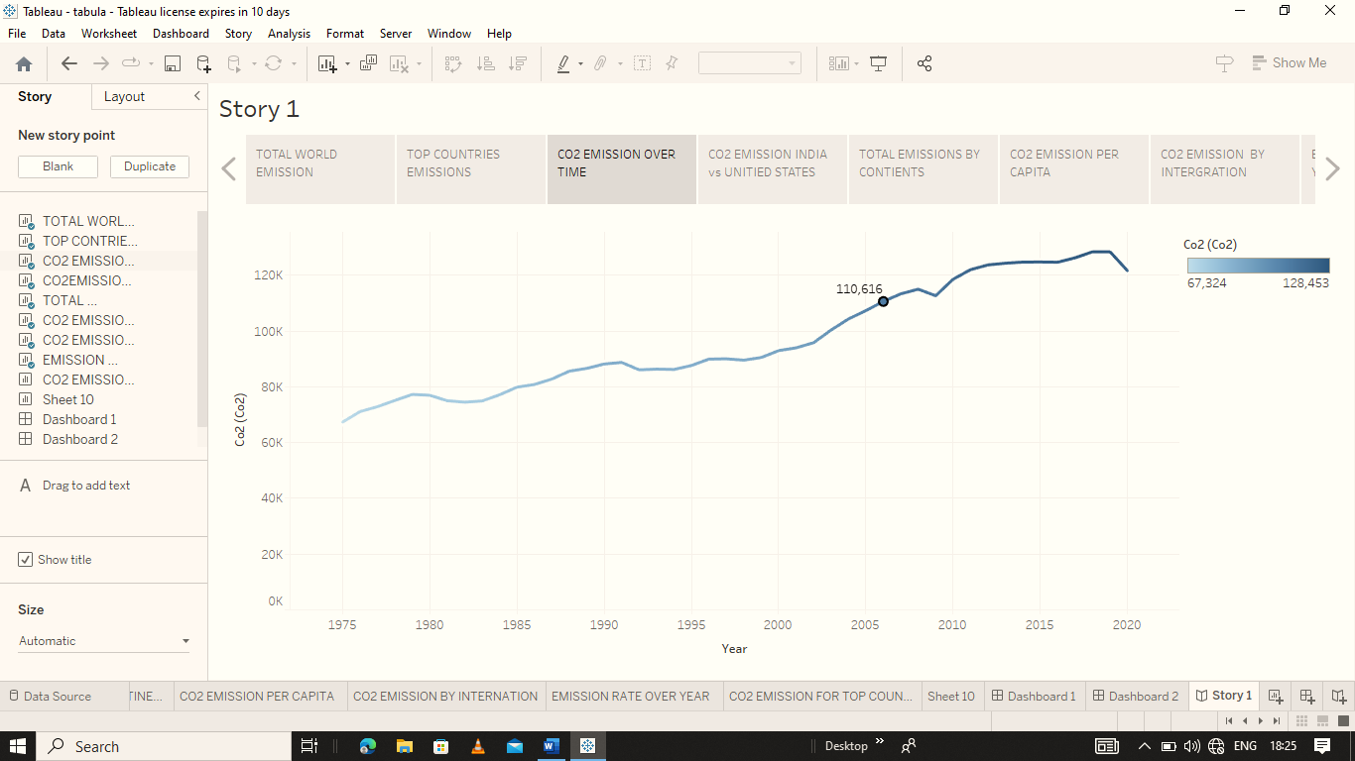

**TOP COUNTRIES EMISSION:**

1. **CHINA**

China is the largest emitter of Co2 gas in world, with 10,668 million metric tons emitted in 2020. The primary source of Co2 emission in China is fossil fuels, most notably those that burn coal. About 55% of the total energy generated by China in 2021 came from coal alone, and because coal I rich in carbon, burning it in China’s power and industrial plant and boilers releases large amounts of Co2 into the atmosphere.

1. **THE U.S.**

The U.S. is the second- largest emitter of Co2 , with 4,713 million metric tons of total carbon dioxide emission in 2020. The largest sources of Co2 emissions in the U.S. came from transportation, power generation, and industry in 2020.

1. **INDIA**

India is the third-largest co2 emitter, with 2,442 million metric tons of total carbon dioxide emission produced in 2020. Coal is the main energy source for India, supplying about 45% of the energy in the country. Petroleum and other liquids provided about 26%.

1. **RUSSIA**

Russia is the fourth- largest contributor to Co2 emission in the world, emitting 1,577 million metric tons in 2020. Russia has one of the largest natural gas deposits in the world, and natural gas is the primary source of energy and power generation in the country. Coal, which is widely used in chemical and other **basic material** industries and for power generation in Russia, is also a major contributor to Russia’s Co2 emissions.

1. **JAPAN**

Japan is the fifth-largest producer of Co2 emissions, with 1,577 million metric tons in 2020. Japan’ s energy fuel mix changed after the 2011 nuclear accident at Fukushima. Oil is the largest source of energy in Japan, with its total share of energy consumption being 40% in 2019.

Coal still makes up a large share of energy consumption in Japan:26% . Nuclear gas is becoming more prominent in Japan after the nuclear disaster and now accounts for 21% of energy consumption as of 2019. The country’s energy plan from 2018 has the goal of increasing nuclear-fired power production by 2030 to reduce the dependency on hydrocarbon fuel import.

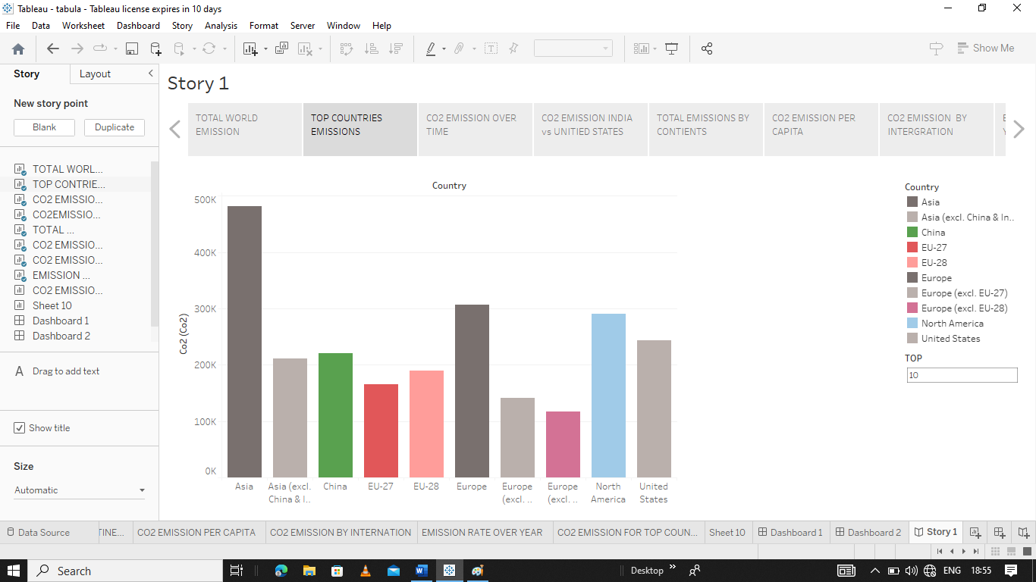

**CO2 EMISSION OVER TIME:**

Carbon dioxide emissions are the primary driver of global climate change. It’s widely recognised that to avoid the worst impacts of climate change, the world needs to urgently reduce emissions. But, how this responsibility is shared between regions, countries, and individuals has been an endless point of contention in international discussions.

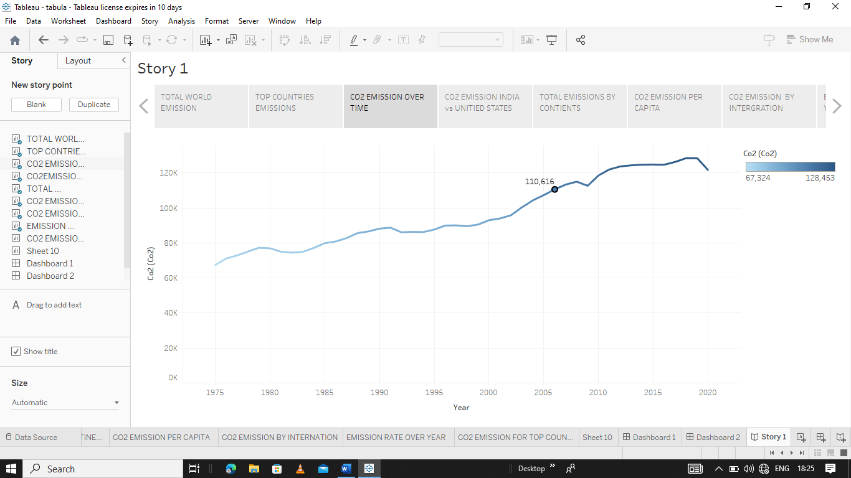

**INDIA VS UNITED STATES:**

At first thought, we might assume that the carbon dioxide we emit from the burning of fossil fuels is exactly the amount that accumulates in the Earth’s atmosphere.

However, the carbon cycle – and factors that determine how much of this CO2 stays in the atmosphere – is a bit more complex than that. In it’s annual review of carbon emissions, the Global Carbon Project produces its [Global Carbon Budget](https://www.icos-cp.eu/global-carbon-budget-2019): this is an estimation of the balance of the various carbon sources and sinks.[4](https://ourworldindata.org/atmospheric-concentrations#note-4)

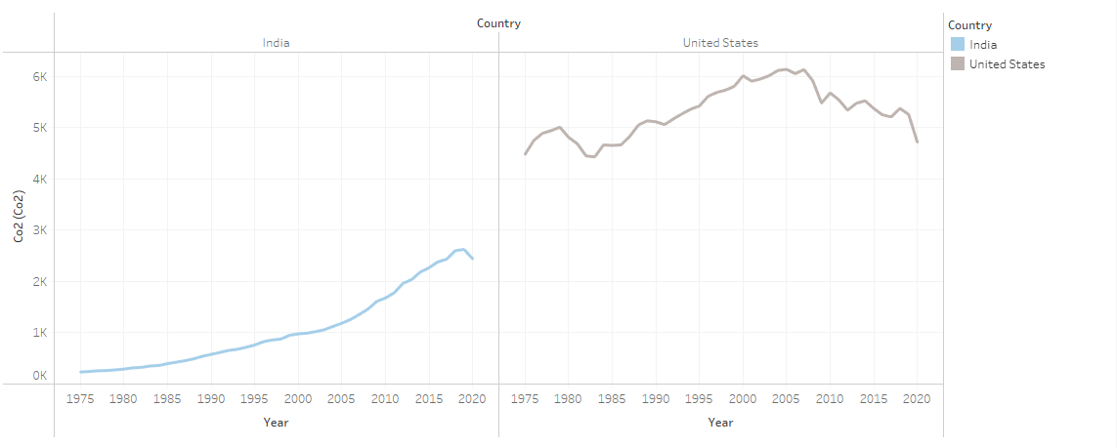

**CO2 EMISSION BY CONTINENTS:**

Carbon dioxide emissions are the primary driver of global climate change. It’s widely recognised that to avoid the worst impacts of climate change, the world needs to urgently reduce emissions. But, how this responsibility is shared between regions, countries, and individuals has been an endless point of contention in international discussions.

This debate arises from the various ways in which emissions are compared: as annual emissions by country; emissions per person; historical contributions; and whether they adjust for traded goods and services. These metrics can tell very different stories.

According to World Green House Gas Emission Data, the correct sequence of countries in decreasing order of their contribution to global carbon dioxide emissions 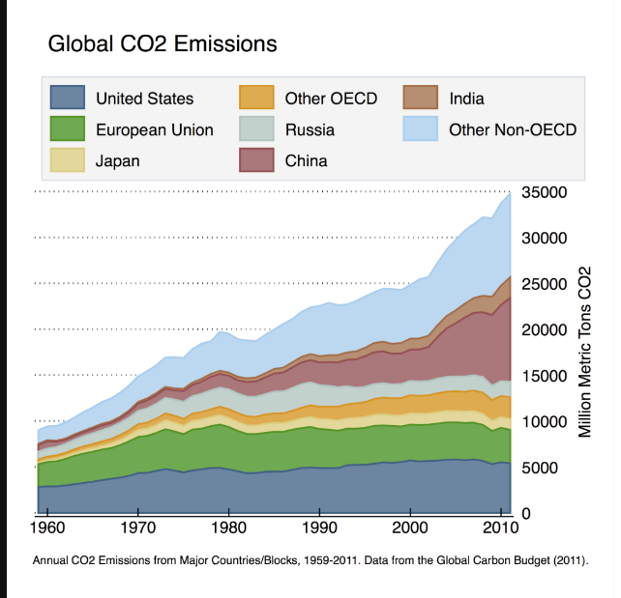**a**.

**CO2 EMISSION BY FOSSIL FUELS:**

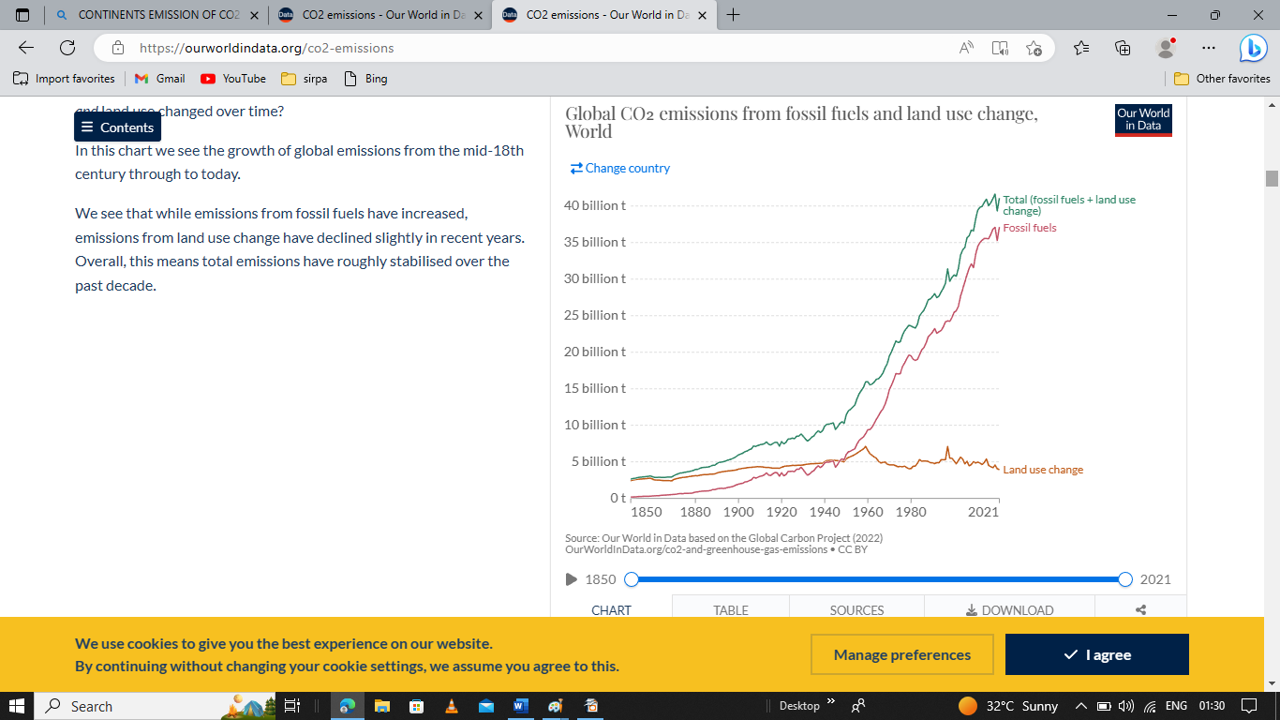

In this chart we see the growth of global emissions from the mid-18th century through to today.

We see that while emissions from fossil fuels have increased, emissions from land use change have declined slightly in recent years. Overall, this means total emissions have roughly stabilised over the past decade.

**DASHBOARD:**

A dashboard is a graphical user interface (GUI) that displays information and data in an organized, easy-to-read format. Dashboards are often used to provide real-time monitoring and analysis of data, and are typically designed for a specific purpose or use case. Dashboards can be used in a variety of settings, such as business, finance, manufacturing, healthcare, and many other industries. They can be used to track key performance indicators (KPIs), monitor performance metrics, and display data in the form of charts, graphs, andtables.

A dashboard is a way of displaying various types of visual data in one place. Usually, a dashboard is intended to convey different, but related information in an easy-to-digest form. And oftentimes, this includes things like key performance indicators (KPI)s or other important business metrics that stakeholders need to see and understand at a glance.

Dashboards are useful across different industries and verticals because they’re highly customizable. They can include data of all sorts with varying date ranges to help you understand: what happened, why it happened, what may happen, and what action you should take. And since dashboards use visualizations like [tables](https://www.tableau.com/data-insights/reference-library/visual-analytics/tables), graphs, and [charts](https://www.tableau.com/data-insights/reference-library/visual-analytics/charts), others who aren’t as close to the data can quickly and easily understand the story it tells or the insights it reveals.

**Data visualization** is a way of presenting data in a visual form to make it easier to understand and analyze.

**Data dashboards** are a summary of different, but related data sets, presented in a way that makes the related information easier to understand. Dashboards are a type of data visualization, and often use common visualization tools such as graphs, charts, and tables.

**DASHBOARD 1**

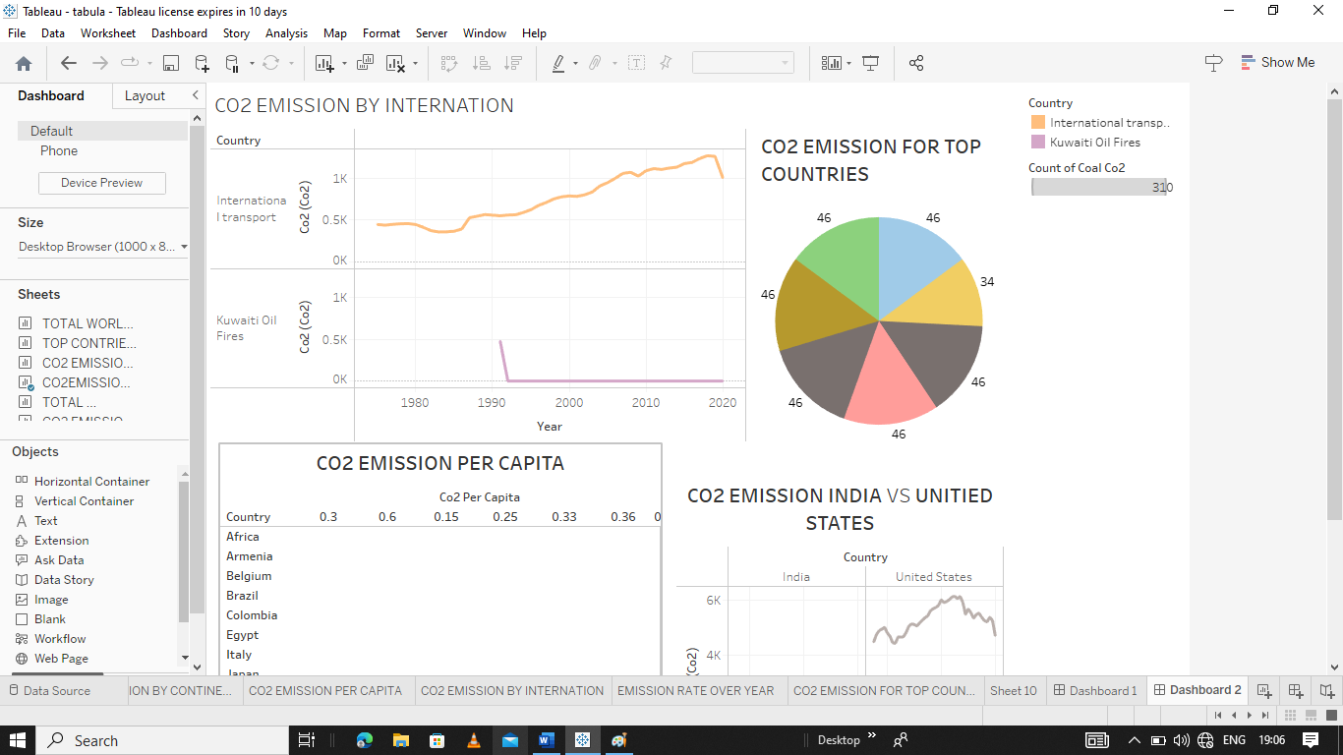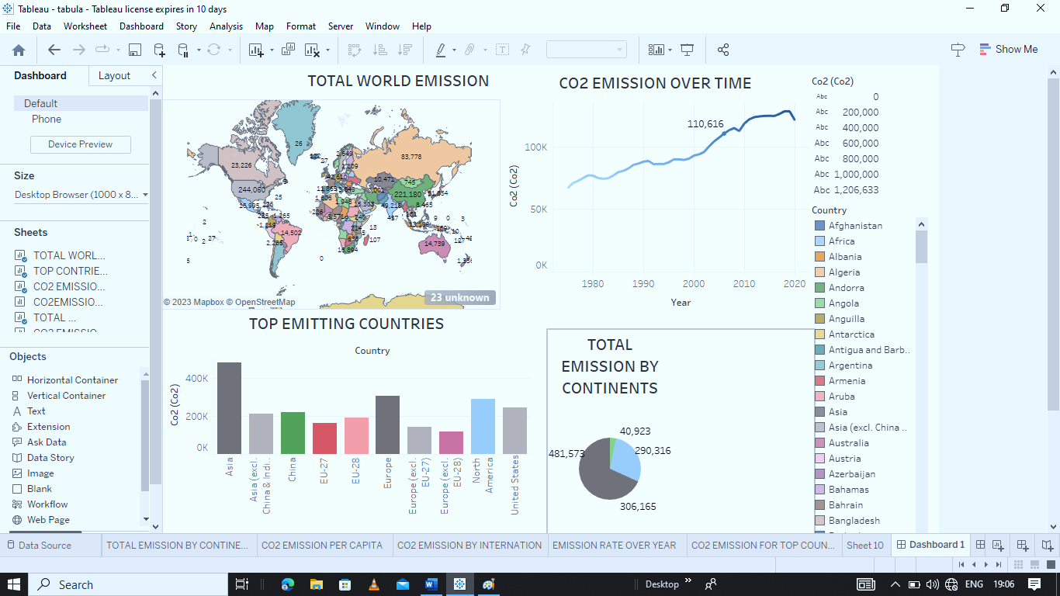

**STORY**

A data story is a way of presenting data and analysis in a narrative format, with the goal of making the information more engaging and easier to understand. A data story typically includes a clear introduction that sets the stage and explains the context for the data, a body that presents the data and analysis in a logical and systematic way, and a conclusion that summarizes the key findings and highlights their implications. Data stories can be told using a variety of mediums, such as reports, presentations, interactive visualizations, and videos.

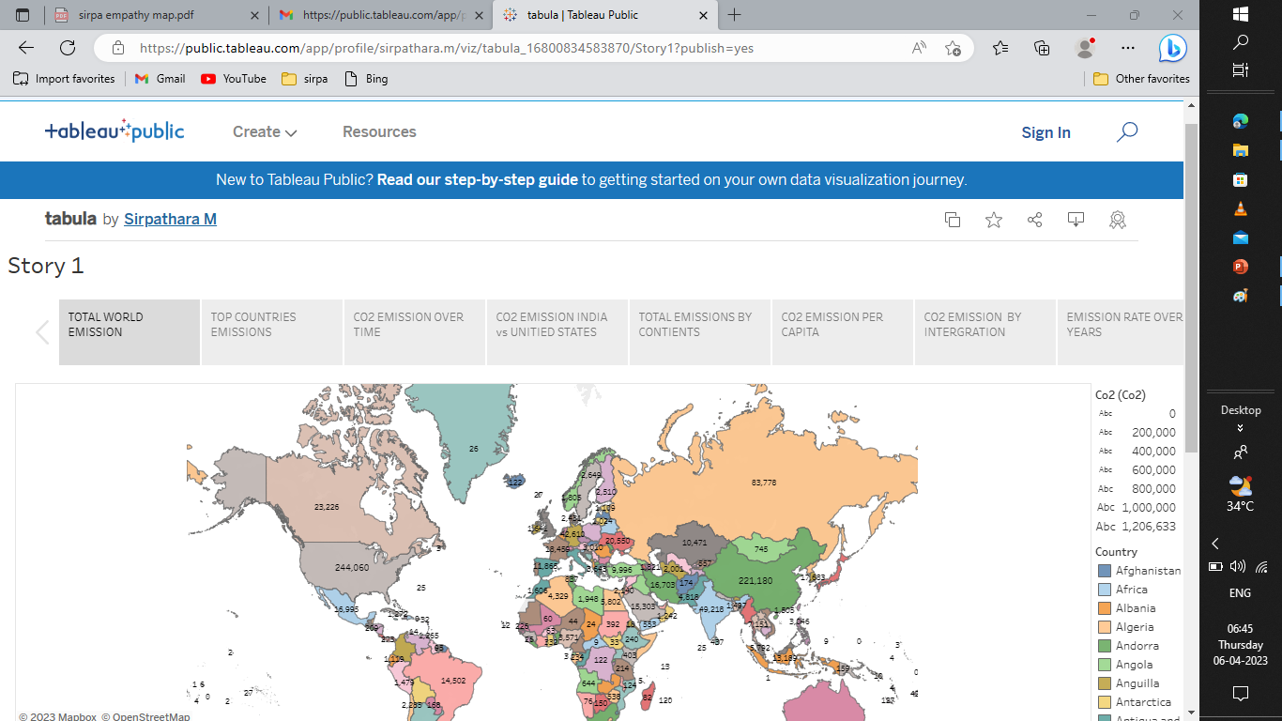

**ADVANTAGES:**

arbon has many uses in various industries. It is used as a**base for ink in inkjet printers, in the manufacture of fizzy and carbonated drinks, and in fire extinguishers**[**1**](https://www.bing.com/ck/a?!&&p=30ed9bde67b8f7caJmltdHM9MTY4MTE3MTIwMCZpZ3VpZD0zN2MyNzU5My04YWY1LTZhMGEtMWE0Yy03YmI2OGI0YTZiYTkmaW5zaWQ9NTQ2OA&ptn=3&hsh=3&fclid=37c27593-8af5-6a0a-1a4c-7bb68b4a6ba9&psq=use+of+carbon&u=a1aHR0cHM6Ly9zY2llbmNlc3RydWNrLmNvbS9jYXJib24tdXNlcy1pbi1ldmVyeWRheS1saWZl&ntb=1). Carbon is essential in cellular respiration to produce energy for human activities, and activated charcoal is used to treat chemical poisonings and drug overdoses[**2**](https://www.bing.com/ck/a?!&&p=48028f19328441e9JmltdHM9MTY4MTE3MTIwMCZpZ3VpZD0zN2MyNzU5My04YWY1LTZhMGEtMWE0Yy03YmI2OGI0YTZiYTkmaW5zaWQ9NTQ2OQ&ptn=3&hsh=3&fclid=37c27593-8af5-6a0a-1a4c-7bb68b4a6ba9&psq=use+of+carbon&u=a1aHR0cHM6Ly9hemNoZW1pc3RyeS5jb20vY2FyYm9uLXVzZXMtaW4tZXZlcnlkYXktbGlmZQ&ntb=1). In the tire industry, carbon is used to strengthen rubber, act as a pigment and UV stabilizer, and as a conductive or insulating agent in rubber, ink, plastic, and coating applications[**3**](https://www.bing.com/ck/a?!&&p=01711df2a341a8c6JmltdHM9MTY4MTE3MTIwMCZpZ3VpZD0zN2MyNzU5My04YWY1LTZhMGEtMWE0Yy03YmI2OGI0YTZiYTkmaW5zaWQ9NTQ3MA&ptn=3&hsh=3&fclid=37c27593-8af5-6a0a-1a4c-7bb68b4a6ba9&psq=use+of+carbon&u=a1aHR0cHM6Ly93d3cuZW1iaWJlLmNvbS9leGFtcy91c2VzLW9mLWNhcmJvbi8&ntb=1). Carbon is also used as a fuel and feedstock for petrochemical industries, and in metal smelting[**4**](https://www.bing.com/ck/a?!&&p=b4bf801ccf9f39d5JmltdHM9MTY4MTE3MTIwMCZpZ3VpZD0zN2MyNzU5My04YWY1LTZhMGEtMWE0Yy03YmI2OGI0YTZiYTkmaW5zaWQ9NTQ3MQ&ptn=3&hsh=3&fclid=37c27593-8af5-6a0a-1a4c-7bb68b4a6ba9&psq=use+of+carbon&u=a1aHR0cHM6Ly93d3cucnNjLm9yZy9wZXJpb2RpYy10YWJsZS9lbGVtZW50LzYvY2FyYm9u&ntb=1). Carbon fibres are used in making tennis rackets, fishing rods, airplanes, and rockets, while industrial diamonds are used for drilling and cutting rocks[**5**](https://www.bing.com/ck/a?!&&p=52ccb4d72b9a74e0JmltdHM9MTY4MTE3MTIwMCZpZ3VpZD0zN2MyNzU5My04YWY1LTZhMGEtMWE0Yy03YmI2OGI0YTZiYTkmaW5zaWQ9NTQ3Mg&ptn=3&hsh=3&fclid=37c27593-8af5-6a0a-1a4c-7bb68b4a6ba9&psq=use+of+carbon&u=a1aHR0cHM6Ly9ieWp1cy5jb20vY2hlbWlzdHJ5L2NhcmJvbi1hbmQtaXRzLWltcG9ydGFuY2Uv&ntb=1).

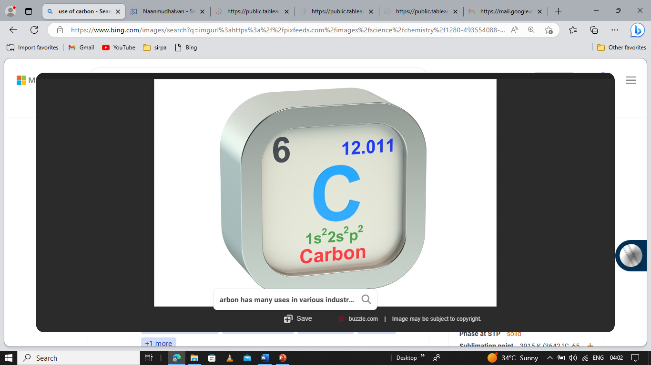

**DISADVANTAGES :**

[**Carbon dioxide gas**](https://www.online-sciences.com/earth-and-motion/the-properties-of-carbon-dioxide-gas/)**can be toxic and very harmful to humans, It increases the temperature of the Earth’s atmosphere, It causes**[**the global warming effect**](https://www.online-sciences.com/earth-and-motion/the-negative-effects-of-the-global-warming-phenomenon-and-how-to-overcome-the-global-warming/)**that has bad effects on the Earth.**

**Increasing the percentage of**[**carbon dioxide gas**](https://www.online-sciences.com/earth-and-motion/the-properties-of-carbon-dioxide-gas/)**in the air causes suffocation of living organisms as well as global warming that threatens the existence of life on this planet, a high concentration of**[**carbon dioxide gas**](https://www.online-sciences.com/chemistry/types-importance-negative-effects-of-chemical-reactions-sulphur-carbon-oxides-harms/)**causes narcosis**

[**Carbon dioxide gas**](https://www.online-sciences.com/earth-and-motion/the-properties-of-carbon-dioxide-gas/)**level increases to higher than 5 % in the room, this ratio is enough to kill the human being, carbon dioxide gas increases the cerebral blood flow and intracranial pressure.**

**CONCLUSION:**

In conclusion, carbon dioxide emission can be**caused either naturally or by the activities of human beings**. High levels of carbon dioxide in the atmosphere can cause adverse effects. These effects include depletion of the ozone layer. Ozone layer depletion causes infiltration of ultraviolet radiation through the earth’s atmosphere.

**FUTURE SCOPE**

the targets for reducing our greenhouse gas (GHG) emissions are highly ambitious. But there is no time to waste. And to meet these targets and protect our future standard of living, countries are now ready to take action. And so are businesses. The European Union’s roadmap, for instance, requires a 55% reduction in GHGs compared with their 1990 level... by 2030